Internet

Inter: Ở giữa

Net: netword

* Internet là mạng lưới kết nối máy tính với nhau

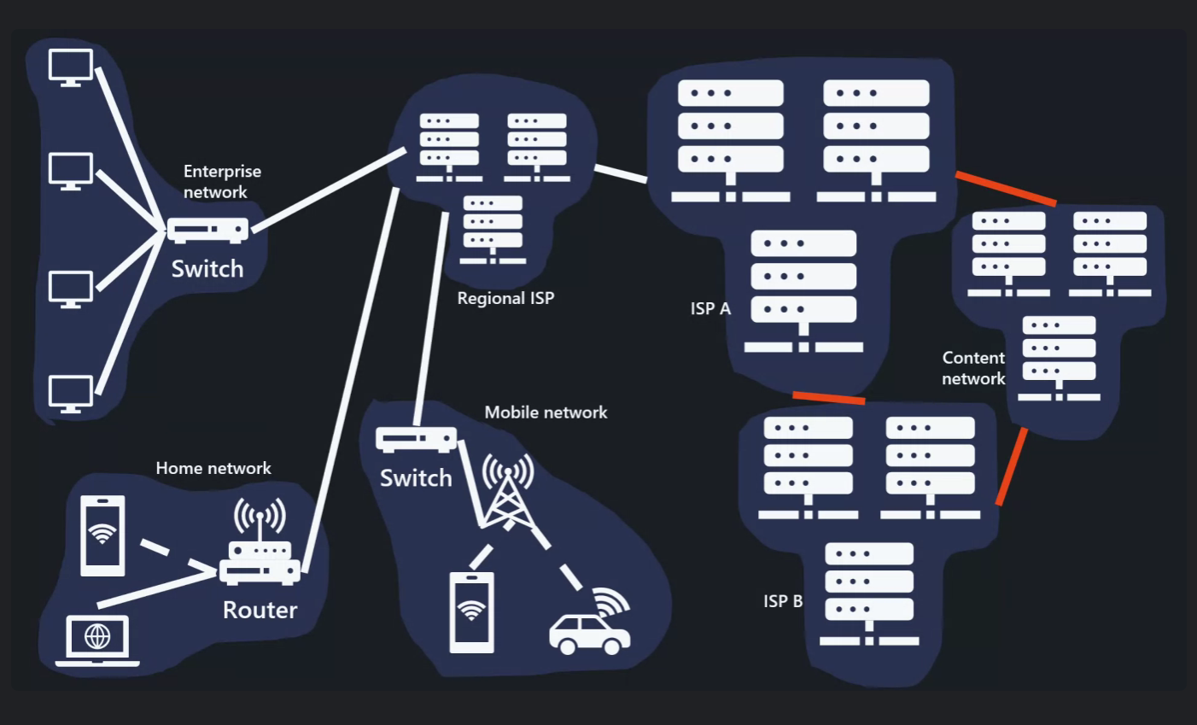

Iso – osi model

Application: function provides network services

Presentation: translates, encrypts, and compresses data

Session: manages sessions or connections between applications

Transport: ensures complete data transfer with error checking and flow control

Network: IP manages data routing and forwarding: fines logical addressing

Data link: provides note to node data transfter error dectection and correction -> switch

Physical: transmit raw bit streams over a physical connections

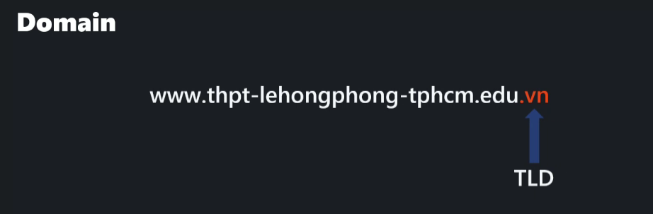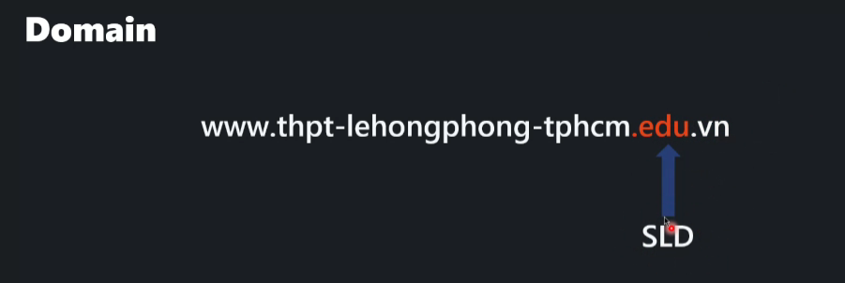

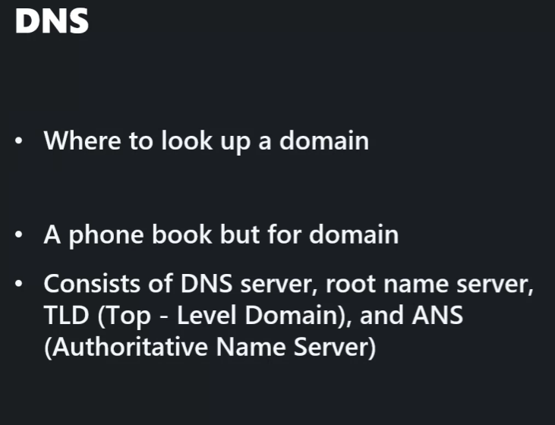

Browser → OS (no cache?) → DNS resolver (no cache?) → ISP (Internet Service Provider, no cache?) → TLD (don’t no that domain but knows which DNS server has it) → returns DNS IP → ISP takes DNS IP and asks that DNS server → DNS server returns web IP → ISP returns IP to our DNS server → our DNS server returns to OS → OS returns to Browser

HyperText Transfer Protocol (Secure): Gửi qua gửi lại cái SYN, SYN-ACK, ACK (xác nhận) rồi bản Secure thì có them private key để bảo mật thông tin